Administrative Department Assessment Report Template
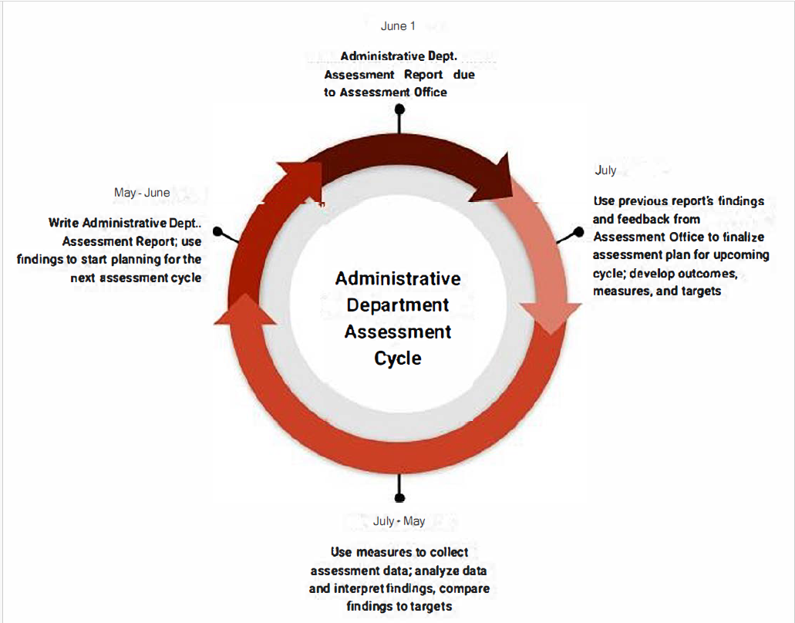
Please read:
- The ultimate goal of the administrative unit assessment process is to seek improvement, not demonstrate performance. In other words, the goal of this process is to document your departments efforts to improve its services, products, processes, and functioning. Outcomes should focus on areas that the department wants to optimize, instead of areas that have already been optimized.
- Please complete the administrative department summary information below.
- Reminders for Table 1: Administrative Unit Outcomes (AUOs).
  - Prompts are provided in each column header to guide you in completing the template.
  - Each department should have a total of 3 to 5 AUOs.
  - Please measure and provide findings and comments on findings for at least 3 of your AUOs each year.
  - All AUOs should be measured at least twice in a 5-year period.
  - An action plan should be provided for AUOs where targets were not met. If all targets are met, please provide an action plan for at least one AUO.
- Reminders for Table 2: Student Learning Outcomes (SLOs).
  - Prompts are provided in each column header to guide you in completing the template.
  - Not all administrative departments will have SLOs. If your department directly impacts student learning and development, you should be measuring at least 1 SLO each year.
  - Please also provide findings and comments on findings for any SLOs measured during the academic year.
  - Please provide an action plan for any SLO where targets were not met.
Reports for the academic year are due by June 1st yearly. Please submit reports to the Assessment Teams folder. Please also feel free to contact the Assessment office assessment@azwestern.edu for additional assistance or guidance. You may also consult the AWC Assessment page for additional information https://www.azwestern.edu/instruction/assessment

Department Summary:
Academic Year
Administrative Dept. Name
Administrative Dept. Lead
Assessment Point of Contact
Mission Statement

How do your department goals link to the college’s Institutional Priorities?
Please list your goals and brief description of how the department goals links to the Institutional Priorities.
- Agility: Cultivate an agile culture and institutional model that strengthens the future of AWC and the region.
- Technology: Improve Student Success by leveraging technology that personalizes the students experience and increase organizational effectiveness.
- Accessibility: Eliminate cultural, financial, time, and place barriers to education.
- Prosperity: Grow and sustain academic programs that leverage our competencies, fuel economic growth and position graduates for prosperity.
Table 1: Administrative Unit Outcomes (AUOs)

Administrative Unit Outcomes (AUOs) | Assessment Measures  Please include a measure for each AUO | Targets  Please include a target for each AUO | Findings from Current Cycle  Please include findings for each AUO measured this year, and please state whether or not each target was met. | Reflecting on Findings  For each AUO measured: What do these findings mean to your unit? When do you plan to measure the outcome again? Are you considering making changes to your assessment plan based on these findings? | Action Planning  Is the department planning any changes or other improvements based on these findings? An action plan should be included for all AUOs with unmet targets. | Reflecting on Past Action Planning  What action plans have been implemented for this outcome in the past? How have those changes affected department quality or efficiency?
AUO #1:

AUO #2:

AUO #3:

AUO #4:

AUO #5:

Table 2: Student Learning Outcomes (SLOs) – if applicable

Student Learning Outcomes (SLOs) | Assessment Measures  Please include a measure for each SLO | Targets  Please include a target for each SLO | Findings from Current Cycle  Please include findings for each SLO measured this year, and please state whether or not each target was met. | Reflecting on Findings  For each SLO measured: What do these findings mean to your unit? When do you plan to measure the outcome again? Are you considering making changes to your assessment plan based on these findings? | Action Planning  Is the unit planning any changes or other improvements based on these findings? An action plan should be included for all SLOs with unmet targets. | Reflecting on Past Action Planning  What action plans have been implemented for this outcome in the past? How have those changes affected student learning?
SLO #1:

SLO #2:

SLO #3:

Feedback on Administrative Department Assessment – optional
- What can the Assessment Office do to better support you and your department in this process?
- What challenges or barriers are making this process more difficult or less useful for you and your unit?
- What changes would you make to the Administrative Department Assessment process?
- What additional information not included in the tables above would you like us to know?

